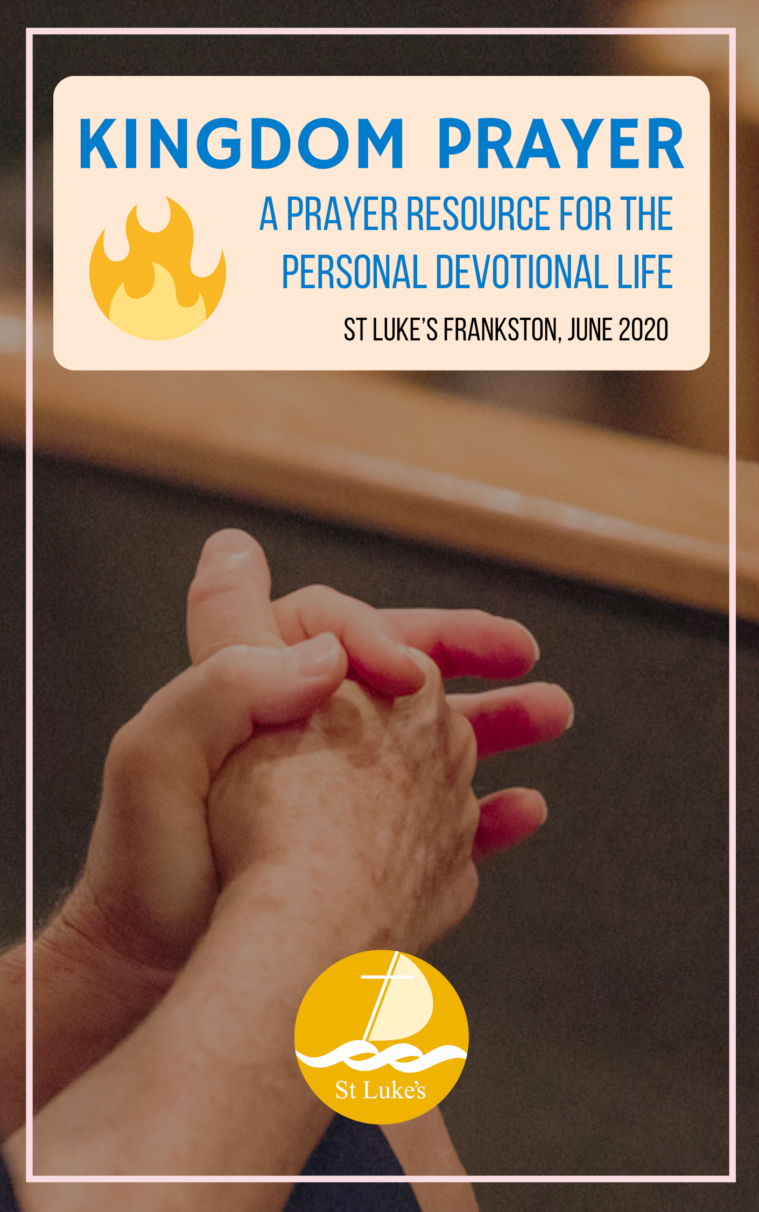
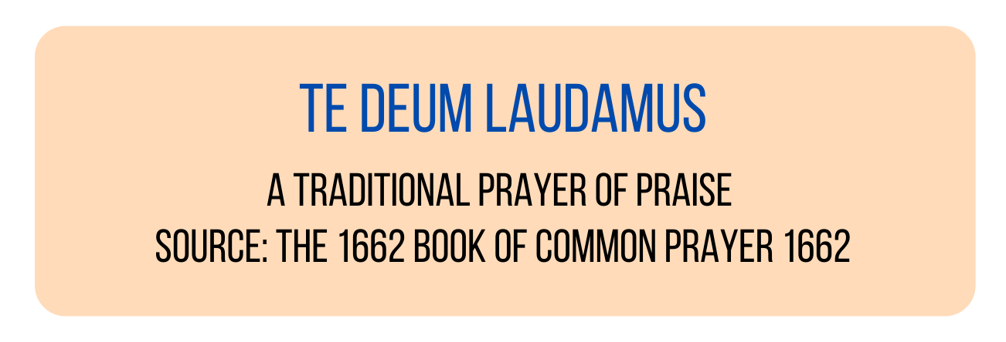
We praise you, O God,
we acclaim you as the Lord;
all creation worships you,
the Father everlasting.
To you all angels, all the powers of heaven,
the cherubim and seraphim, sing in endless praise:
Holy, holy, holy Lord, God of power and might,
heaven and earth are full of your glory.
The glorious company of apostles praise you.
The noble fellowship of prophets praise you.
The white-robed army of martyrs praise you.
Throughout the world the holy Church acclaims you:
Father, of majesty unbounded,
your true and only Son, worthy of all praise,
the Holy Spirit, advocate and guide.
You, Christ, are the King of glory,
the eternal Son of the Father.
When you took our flesh to set us free
you humbly chose the Virgin’s womb.
You overcame the sting of death
and opened the kingdom of heaven to all believers.
You are seated at God’s right hand in glory.
We believe that you will come and be our judge.
Come then, Lord, and help your people,
bought with the price of your own blood,
and bring us with your saints
to glory everlasting.

Lord, our refuge and hope: helps us to consecrate ourselves untiringly to your service with a deep love for you and for our brothers and sisters, until the day comes when we shall see the vision of your face in the kingdom of Jesus Christ your Son our Lord. Amen.

Lighten our darkness, Lord, we pray: and in your great mercy defend us from all the perils and dangers of this night; for the love of your only Son our Saviour Jesus Christ. Amen.

Vision Direction - Grow Towards Maturity
Primary Objective 1: Grow children and youth to be more resilient
Primary Objective 2: Grow everyone everyday
Primary Objective 3: Grow together

Vision Direction - Make a Deeper Difference
Primary Objective 4: Focus our efforts so as to deepen our impact
(Please see flier ‘St Luke’s Frankston: 2020-2025 Vision- Next Steps’ for further information).

